**AND PERCEPTRON IMPLEMENTATION**

Basic Perceptron Equation :

w1*x1 +w2*x2 +b, if w1*x1 +w2*x2 +b >0 => 1, else 0

Consider w1=w2=1, b=-1

1. X1=1, x2=1

1(1) + 1(1) -1 = 1 => o/p=1 TRUE

1. X1=0, x2=0

1(0) + 1(0) -1 = -1 => o/p=0 TRUE

1. X1=0, x2=1

1(0) + 1(1) -1 = 0 => o/p=0 TRUE

Hence , Final Equation => x1 +x2 -1

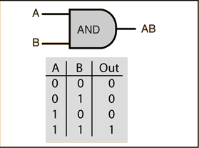

**OR PERCEPTRON IMPLEMENTATION**

Basic Perceptron Equation :

w1*x1 +w2*x2 +b, if w1*x1 +w2*x2 +b >0 => 1, else 0

Consider w1=w2=1, b=-1

1. X1=1, x2=1

1(1) + 1(1) -1 = 1 => o/p=1 TRUE

1. X1=0, x2=0

1(0) + 1(0) -1 = -1 => o/p=0 TRUE

1. X1=0, x2=1

1(0) + 1(1) -1 = 0 => o/p=0 FALSE,

so change w2=2 ,

1(0) + 2(1) -1 = 1 => o/p = 1 TRUE

1. X1=1, x2=0

1(1) + 1(0) -1 = 0 => o/p=0 FALSE,

so change w1=2 ,

2(1) + (1) -1 = 1 => o/p = 1 TRUE

Hence , Final Equation => 2(x1) +2(x2) -1

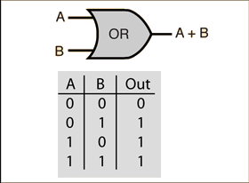

**NOT PERCEPTRON IMPLEMENTATION**

Basic Perceptron Equation :

w1*x1 +b, if w1*x1 +b >0 => 1, else 0 (single input x1)

Consider w1=1, b=-1

1. X1=1

1(1) -1 =0 => o/p=0 TRUE

1. X2=0

1(0) -1 = -1 => o/p=0 FALSE

So change b=1

1(0)+1 =1 => o/p=1 TRUE , but statement 1 not satisfied.

Change w1= -1

Hence Final Equation => -1(x1) +1 or -x1+1

